Computing environments
Computing environments refer to the technology infrastructure and software platforms that are used to develop, test, deploy, and run software applications. There are several types of computing environments, including:
- Mainframe: A large and powerful computer system used for critical applications and large-scale data processing.
- Client-Server: A computing environment in which client devices access resources and services from a central server.
- Cloud Computing: A computing environment in which resources and services are provided over the Internet and accessed through a web browser or client software.
- Mobile Computing: A computing environment in which users access information and applications using handheld devices such as smartphones and tablets.
- Grid Computing: A computing environment in which resources and services are shared across multiple computers to perform large-scale computations.
- Embedded Systems: A computing environment in which software is integrated into devices and products, often with limited processing power and memory.

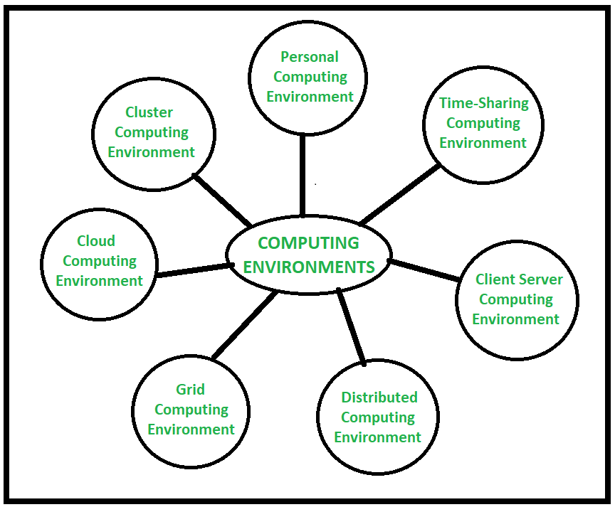
- Personal Computing Environment : In personal computing environment there is a stand-alone machine. Complete program resides on computer and executed there. Different stand-alone machines that constitute a personal computing environment are laptops, mobiles, printers, computer systems, scanners etc. That we use at our homes and offices.
- Time-Sharing Computing Environment : In Time Sharing Computing Environment multiple users share system simultaneously. Different users (different processes) are allotted different time slice and processor switches rapidly among users according to it. For example, student listening to music while coding something in an IDE. Windows 95 and later versions, Unix, IOS, Linux operating systems are the examples of this time sharing computing environment.
- Client Server Computing Environment : In client server computing environment two machines are involved i.e., client machine and server machine, sometime same machine also serve as client and server. In this computing environment client requests resource/service and server provides that respective resource/service. A server can provide service to multiple clients at a time and here mainly communication happens through computer network.
- Distributed Computing Environment : In a distributed computing environment multiple nodes are connected together using network but physically they are separated. A single task is performed by different functional units of different nodes of distributed unit. Here different programs of an application run simultaneously on different nodes, and communication happens in between different nodes of this system over network to solve task.
- Grid Computing Environment : In grid computing environment, multiple computers from different locations works on single problem. In this system set of computer nodes running in cluster jointly perform a given task by applying resources of multiple computers/nodes. It is network of computing environment where several scattered resources provide running environment for single task.
- Cloud Computing Environment : In cloud computing environment on demand availability of computer system resources like processing and storage are availed. Here computing is not done in individual technology or computer rather it is computed in cloud of computers where all required resources are provided by cloud vendor. This environment primarily comprised of three services i.e software-as-a-service (SaaS), infrastructure-as-a-service (IaaS), and platform-as-a-service (PaaS).
- Cluster Computing Environment : In cluster computing environment cluster performs task where cluster is a set of loosely or tightly connected computers that work together. It is viewed as single system and performs task parallelly that’s why also it is similar to parallel computing environment. Cluster aware applications are especially used in cluster computing environment.
- Personal Computing Environment : In personal computing environment there is a stand-alone machine. Complete program resides on computer and executed there. Different stand-alone machines that constitute a personal computing environment are laptops, mobiles, printers, computer systems, scanners etc. That we use at our homes and offices.
- Time-Sharing Computing Environment : In Time Sharing Computing Environment multiple users share system simultaneously. Different users (different processes) are allotted different time slice and processor switches rapidly among users according to it. For example, student listening to music while coding something in an IDE. Windows 95 and later versions, Unix, IOS, Linux operating systems are the examples of this time sharing computing environment.
- Client Server Computing Environment : In client server computing environment two machines are involved i.e., client machine and server machine, sometime same machine also serve as client and server. In this computing environment client requests resource/service and server provides that respective resource/service. A server can provide service to multiple clients at a time and here mainly communication happens through computer network.
- Distributed Computing Environment : In a distributed computing environment multiple nodes are connected together using network but physically they are separated. A single task is performed by different functional units of different nodes of distributed unit. Here different programs of an application run simultaneously on different nodes, and communication happens in between different nodes of this system over network to solve task.
- Grid Computing Environment : In grid computing environment, multiple computers from different locations works on single problem. In this system set of computer nodes running in cluster jointly perform a given task by applying resources of multiple computers/nodes. It is network of computing environment where several scattered resources provide running environment for single task.
- Cloud Computing Environment : In cloud computing environment on demand availability of computer system resources like processing and storage are availed. Here computing is not done in individual technology or computer rather it is computed in cloud of computers where all required resources are provided by cloud vendor. This environment primarily comprised of three services i.e software-as-a-service (SaaS), infrastructure-as-a-service (IaaS), and platform-as-a-service (PaaS).
- Cluster Computing Environment : In cluster computing environment cluster performs task where cluster is a set of loosely or tightly connected computers that work together. It is viewed as single system and performs task parallelly that’s why also it is similar to parallel computing environment. Cluster aware applications are especially used in cluster computing environment.

